06/07/2023

**rules for identifiers**

1. identifiers should not start from numeric

2. case sensitive

3. no limit in word

4. we can add numeric after using the aplhabet

5. we can not use special character and reserve word as idnetifiesrs

**there are 32 keywords in python**

datatype are of two types

1. premitive type

2. non premitive type

**premitive**

1. int

2. float

3. complex

4. bool

5. bytes

6. String

**non-premitive type**

1. range

2. list

3. tuple

4. set

5. dictionary

6. none

7. frozen

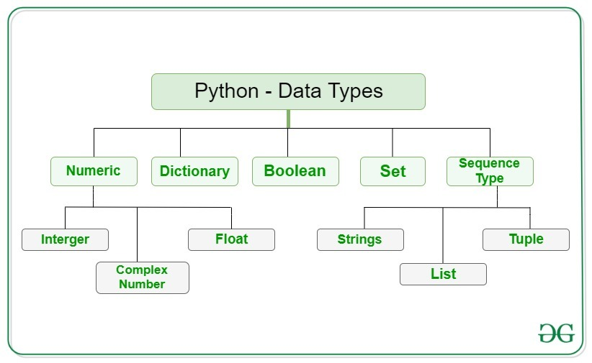

18/07/2023

Int data type

e.g a = 10

type(a) #int

**decimal form(base-10):**

it is the default number system in python

The allowed digits are:0 to 9

Eg.

A =10

Octal form(Base-8):

The allowed digits are 0 to 7 literal value should be prefixed with 0o or 0O.

Eg a =0o123

A =0o786

HEXA DECIMAL FORM(BASE -16)

**BASE CONVERSIONS**

Python provide the following in-built functions for base conversion

1. Bin()
2. Oct()

FLOAT DATA TYPE:

Complex Data Type

Bool Data Type

STR Type

Slicing of String

Slice means a piece

[] operator is called slice operator, which

TYPE CASTING

We can convert one type value to another type. This conversion is called Typecasting or Type coercion. The following are various inbuilt functions for type casting.

1. Int()
2. Float()
3. Complex()
4. Bool()
5. Str()

Fundamental data type vs immutability

All fundamental data types are immutable, i.e once we creates an object

Bytearray data type

Bytearray is exactly same as bytes data types except that is elements can be modified

List data type

Instertion order is preserved

Heterogenous objects are allowed

Tuple data type

Range data type

Set data type

If we want to represent a group of values without duplicates where order is not

Frozenset data type